1. INTRODUCTION

**1.1 Introduction**

Traffic congestion and road safety are among the most pressing concerns in urban mobility, affecting millions of commuters daily. With the rapid increase in vehicle ownership, cities worldwide face growing challenges in managing traffic flow, reducing congestion, and ensuring compliance with traffic rules. In India, where road traffic is highly dynamic, the issue of helmet non-compliance among motorcyclists significantly contributes to road fatalities. The inefficiency of manual enforcement methods and the limitations of traditional traffic monitoring systems have led to the need for automated, AI- driven solutions.

The lack of real-time adaptability in conventional traffic systems results in inefficient traffic flow management, unnecessary delays, and increased accident rates. Fixed-timer traffic signals and manual traffic monitoring by law enforcement officers are outdated methods that fail to address real-time road conditions effectively. Additionally, violations such as red-light jumping, unauthorized lane usage, and helmet non-compliance by motorcyclists remain major concerns. An innovative solution that integrates artificial intelligence (AI), computer vision, and the Internet of Things (IoT) is needed to optimize traffic management and enhance road safety.

Motorcyclists are among the most vulnerable road users, accounting for a significant percentage of road accident fatalities. The National Crime Records Bureau (NCRB) reported that a substantial number of road deaths in India involve two-wheeler riders, many of whom were not wearing helmets. Head injuries resulting from motorcycle accidents are often fatal, and studies have shown that helmet usage can reduce the risk of severe injuries by up to 70%.

Despite mandatory helmet laws, enforcement remains a challenge due to the limitations of manual monitoring. Traffic officers can only monitor a limited number of vehicles at any given time, leading to inconsistent enforcement. Furthermore, non- compliant riders often evade checkpoints, making it difficult for authorities to ensure

widespread adherence to helmet laws. An automated system capable of detecting helmet violations in real-time and issuing penalties would significantly improve compliance and reduce accident-related fatalities.

Traditional traffic management relies on several methodologies, including manual enforcement, CCTV-based monitoring, fixed-timer traffic signals, and RFID-based tracking. However, these methods have notable shortcomings that limit their effectiveness. Manual traffic monitoring relies on traffic police officers to observe and fine violators, leading to inconsistent enforcement and inefficiencies due to human limitations. CCTV surveillance provides recorded evidence of violations, but most systems require human intervention to review footage, leading to delays in enforcement. Fixed-timer traffic signals operate on predefined cycles without adapting to real-time traffic conditions, resulting in increased congestion and unnecessary fuel consumption. RFID-based tracking requires vehicles to be equipped with RFID tags, which is impractical for widespread use and does not support real-time detection of traffic rule violations.

Given these limitations, there is a strong demand for an intelligent traffic monitoring system that leverages AI and computer vision to automate violation detection and enhance traffic flow management. Recent advancements in AI and IoT have paved the way for the development of smart traffic management systems. AI-driven object detection models, such as YOLO (You Only Look Once), enable real-time identification of traffic violations, including helmet non-compliance, red-light jumping, and unauthorized lane changes. IoT- enabled devices, such as the ESP32-CAM module, allow for seamless data collection, processing, and transmission to central traffic management authorities.

The integration of AI and IoT offers several advantages. Automated violation detection ensures accurate and real-time identification of helmet violations without human intervention. Traffic density classification using AI algorithms analyzes vehicle density at intersections, optimizing traffic signal durations dynamically. IoT-enabled modules transmit real-time traffic data to central servers, facilitating instant law enforcement actions. AI-driven systems can be deployed across multiple intersections without significant infrastructure changes, making them highly scalable and cost-efficient.

To address the existing challenges in traffic monitoring and rule enforcement, this project proposes a real-time, AI-powered traffic violation detection system. The system integrates ESP32-CAM modules, the YOLO object detection model, and cloud-based data processing to ensure seamless traffic management. Key functionalities of the proposed system include helmet-wearing detection, where the system captures real-time images of motorcyclists and identifies helmet compliance using deep learning algorithms. Traffic density classification enables AI models to analyze vehicle density and adjust signal durations dynamically to optimize traffic flow. Violation logging and reporting allow the system to log detected violations with timestamps and location details, transmitting data to traffic authorities for enforcement. Wireless data transmission using ESP32 microcontrollers enables real-time communication with cloud servers, allowing instant updates on traffic conditions. A dashboard for law enforcement provides authorities with real-time insights, enabling data-driven decision-making for better urban traffic management.

The proposed system offers multiple benefits over traditional traffic monitoring methods. Increased enforcement efficiency is achieved as automated detection eliminates the need for manual monitoring, ensuring consistent and fair enforcement of traffic laws. Reduction in traffic congestion is facilitated through adaptive traffic signal control that optimizes vehicle movement, minimizing delays and improving road efficiency. Enhanced road safety is ensured as the system significantly reduces head injury-related fatalities in motorcycle accidents by enforcing helmet compliance. Cost-effective deployment is made possible through the use of ESP32-CAM and AI models, allowing for low-cost implementation and making it feasible for large-scale deployment. Scalability and integration are achieved as the system can be expanded to include additional features, such as automatic number plate recognition (ANPR) and predictive analytics for congestion forecasting.

**1.2 Background of the Study *(Expanded Version – 4 to 5 pages content)***

In recent decades, the rapid growth in population, urbanization, and vehicle ownership has led to severe traffic congestion in most urban areas around the world. The growing number of vehicles on the road not only increases travel time but also contributes to air pollution, fuel consumption, and road rage. Efficient traffic management has thus become an essential requirement for modern cities.

Traditionally, traffic signals operate on predefined fixed cycles. For example, a signal may stay green for 60 seconds for one lane, regardless of how many vehicles are waiting. This results in wastage of time and inefficient movement, especially when the actual number of vehicles may not justify the allocated green time.

This leads to:

* Longer waiting times at empty roads.
* Unnecessary fuel consumption during idling.
* Increased emissions contributing to air pollution.
* Frustration among drivers, leading to traffic rule violations.

**Evolution of Traffic Control**

Initially, traffic control was done manually by traffic police officers at intersections. Then came time-based automatic signals, which ran on set schedules. These systems worked fairly well in earlier days when traffic was predictable and consistent. However, in today’s scenario, traffic patterns are dynamic and unpredictable. Fixed-time systems are not sufficient to handle the complexities of modern traffic.

**Smart Traffic Management**

With the advancement of Artificial Intelligence (AI) and Computer Vision, cities are now exploring Smart Traffic Management Systems that can adapt to real-time traffic flow. One such innovation is the use of YOLO (You Only Look Once) for object detection, specifically for detecting vehicles in traffic footage. YOLO is a real-time object detection algorithm that processes images quickly and accurately, making it ideal for live video analysis.

**Advantages of YOLO in Traffic Applications:**

* Real-time detection of vehicles, pedestrians, and other objects.
* High accuracy in detecting vehicles even under different lighting conditions.
* Capability to classify traffic intensity (low, medium, high) based on the number of vehicles detected.
* Integrates well with adaptive traffic control systems.

The aim of our study is to implement YOLO in a real-time traffic monitoring setup to automatically classify the traffic intensity and use this information to adjust traffic signal timings dynamically. This approach falls under the umbrella of Intelligent Transportation Systems (ITS).

**Real-Life Use Cases of AI in Traffic:**

1. India – Surat Smart City Project: Adaptive signal control based on traffic volume improved traffic flow during peak hours.
2. China – Hangzhou: AI-based systems reduced congestion by analyzing video feeds and predicting traffic buildup.
3. USA – San Diego: Smart intersections with object recognition improved traffic flow and pedestrian safety.

These examples show that AI-based systems are the future of traffic control, and this project aims to bring similar innovation into a practical, scalable model using open-source tools.

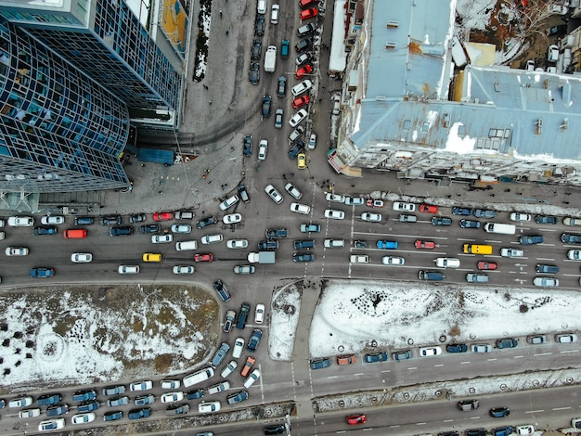

**Figure 1.1: Global urban traffic congestion**

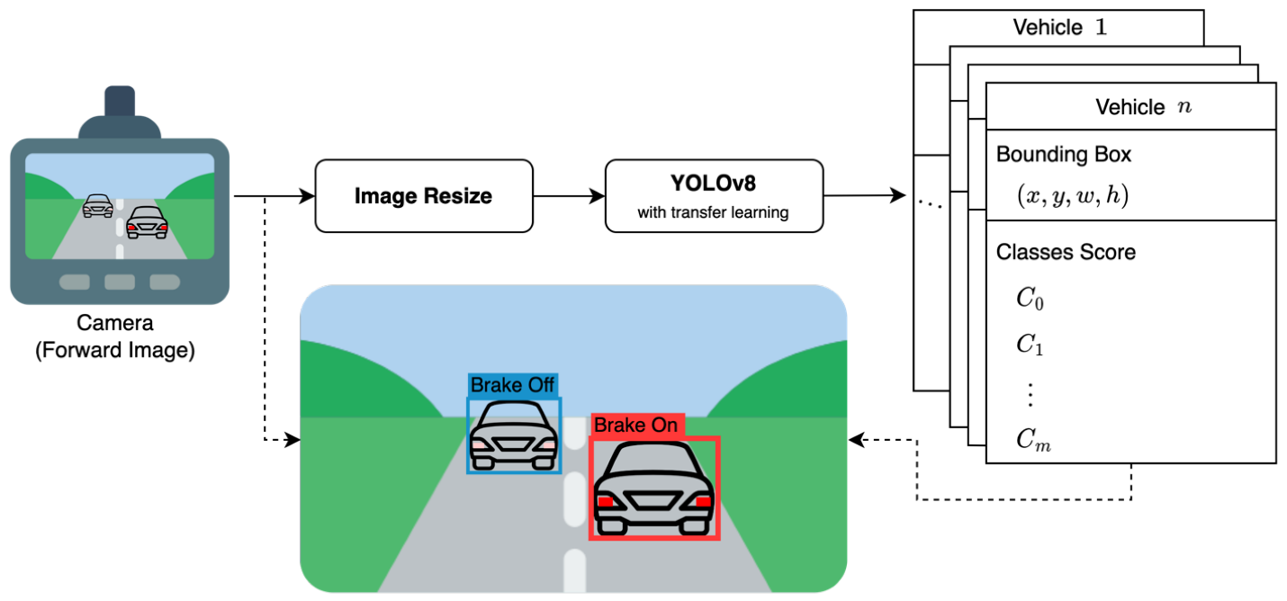

**Figure 1.2: YOLO working process**

**Technologies Enabling Smart Traffic**

The core technologies that empower our solution include:

|  |  |
| --- | --- |
| Technology | Role |
| YOLO (v5/v7) | Real-time object detection |
| OpenCV | Image processing & video analysis |
| Python | Backend programming & control logic |
| Arduino / Raspberry Pi | Hardware for signal control (optional) |
| Cloud / Local Server | For data handling and analytics |
| Camera Feed / CCTV | Real-time video input |

With the integration of these technologies, our system continuously monitors the traffic at an intersection and adjusts the green signal duration accordingly.

**Challenges in Existing Systems:**

|  |  |
| --- | --- |
| **Challenge** | **Explanation** |
| Fixed signal cycles | Unresponsive to real-time traffic needs |
| Manual monitoring | Requires human effort and is error-prone |
| Lack of scalability | Hard to manage multiple intersections |
| No vehicle classification | Cannot differentiate between types (bike, car, truck) |

Our proposed system aims to overcome all of these by using AI-powered automation, reducing human dependency, improving traffic flow, and enabling city-wide scalability.

In addition to solving traffic congestion, AI-based adaptive traffic systems can also contribute to data-driven urban planning. By continuously collecting data on vehicle flow, time of congestion, and traffic hotspots, city authorities can make informed decisions on road expansions, diversions, and even public transport optimization. Over time, such systems can help build a centralized traffic database that predicts traffic surges during festivals, emergencies, or peak office hours. This predictive capability is invaluable for emergency response teams, logistics companies, and even daily commuters, making smart traffic management not just a technological upgrade, but a transformative solution for sustainable urban living.

The study has the potential to:

* Reduce traffic congestion.
* Improve fuel efficiency.
* Lower carbon emissions.
* Enhance road safety.
* Reduce manpower requirement.
* Provide a scalable model for smart city integration.

This makes our project highly relevant and impactful, especially in countries like India where traffic management is a persistent issue.

**1.3 Objectives**

The fundamental objective of this project is to design and implement an intelligent, real-time traffic signal control system that dynamically responds to current traffic conditions using artificial intelligence (AI). With the increasing number of vehicles on the road and the limitations of conventional timer-based traffic control systems, the need for a smarter and more efficient solution is more urgent than ever. Traditional systems operate on fixed time cycles regardless of actual traffic flow, leading to unnecessary delays, increased congestion, and fuel wastage. This project aims to overcome these limitations by deploying the YOLO (You Only Look Once) deep learning algorithm to detect and classify traffic intensity, thereby allowing adaptive signal control based on real-time conditions.

The YOLO algorithm, known for its high accuracy and real-time processing capability, is integrated into a computer vision-based system that processes live camera feeds installed at traffic intersections. The algorithm identifies and counts the number of vehicles present in each lane, classifying the traffic as low, medium, or high intensity. Based on this classification, the signal durations are adjusted to allocate more time to busier roads and less time to less crowded ones. This responsive mechanism not only improves vehicle throughput but also reduces unnecessary waiting times for commuters. By optimizing traffic flow in real-time, the system helps to significantly reduce carbon emissions caused by idling vehicles and contributes to a greener, more sustainable urban environment.

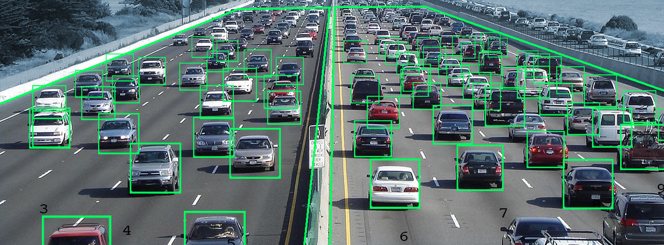

**Figure 1.3: YOLO algorithm detecting vehicles**

Another core objective of this study is to develop a working prototype that can be simulated and tested in both controlled and semi-real-world environments. This prototype will serve as proof of concept, showcasing how adaptive traffic control works in comparison to conventional systems. The system will be tested using real traffic footage from selected urban intersections, and results will be recorded to demonstrate performance improvements. Metrics such as average vehicle waiting time, lane clearance time, fuel consumption, and throughput will be used to compare the two models. This will help validate the practicality and efficiency of the AI-based adaptive control mechanism.

In addition, the project aims to design a scalable architecture that can be easily deployed in any urban city with minimal infrastructure changes. The solution is built to be cost-effective and modular, making it accessible to developing cities and urban planners with limited budgets. By using existing CCTV infrastructure or low-cost IP cameras along with open-source deep learning models, the system minimizes overall implementation cost. Moreover, the traffic classification logic is flexible enough to be updated or trained further as traffic patterns evolve or as city layouts change.

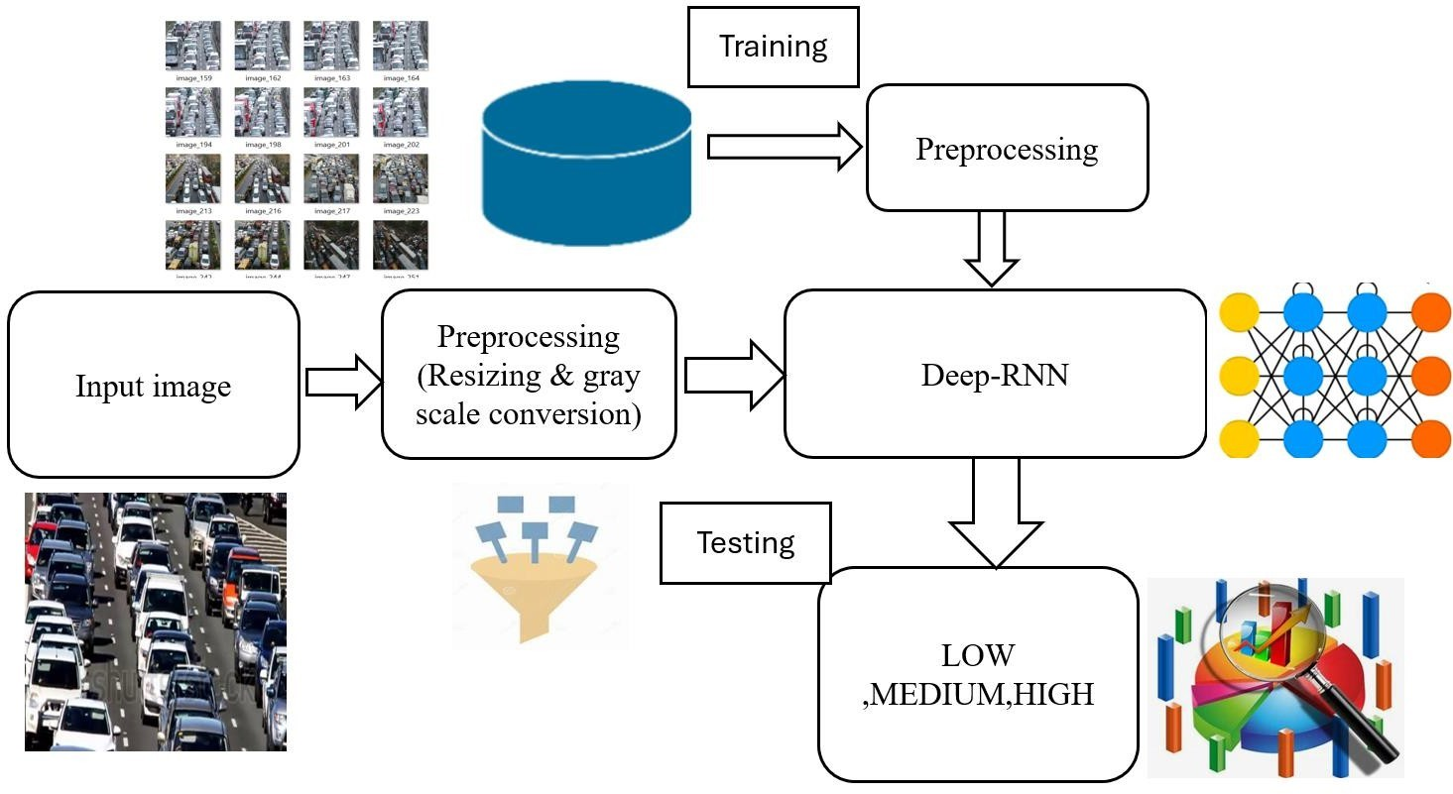

**Figure 1.4: process from live traffic feed input**

Another key objective is to analyze real-world user data through surveys and field studies to understand the existing pain points of commuters. Field surveys, observational studies, and online questionnaires (Google Forms) will be conducted to collect public opinion on traffic-related frustrations, average wait times, satisfaction with current traffic systems, and openness to adopting AI-based solutions. These insights will support the problem statement and help tailor the final model to match user expectations. The survey results will also contribute to policy recommendations for smart traffic management in urban development plans.

Moreover, this project looks forward to the future of intelligent transportation systems (ITS). One of the long-term goals is to integrate this traffic system with a centralized smart city dashboard where multiple intersections can be monitored and controlled from a single control room. The system can also be enhanced to detect emergency vehicles such as ambulances and fire trucks, giving them automatic right of way by switching the signals accordingly. Similarly, pedestrian detection modules and weather-adaptive systems (e.g., giving longer signal times during rainy conditions) can be added to make the system even more robust and user-friendly.

This study also aims to explore integration with IoT devices and cloud-based systems. A cloud-connected version of the system would allow for data to be stored and analyzed at scale, enabling advanced analytics and city-wide traffic prediction models. Integration with mobile apps could provide users with real-time updates on signal changes or recommend alternate routes. These future objectives are intended to demonstrate the long-term vision of the project and its potential to evolve into a complete smart traffic ecosystem.

In summary, this project is driven by the goal of transforming outdated traffic systems into intelligent, data-driven models that reflect real-time urban mobility needs. By leveraging computer vision, deep learning, and adaptive control algorithms, the proposed system can deliver smoother traffic flow, enhanced commuter experience, and measurable environmental benefits. The ultimate objective is not only to solve current traffic challenges but also to lay the foundation for future smart city technologies that are responsive, efficient, and sustainable.

**1.4 Block Diagram**

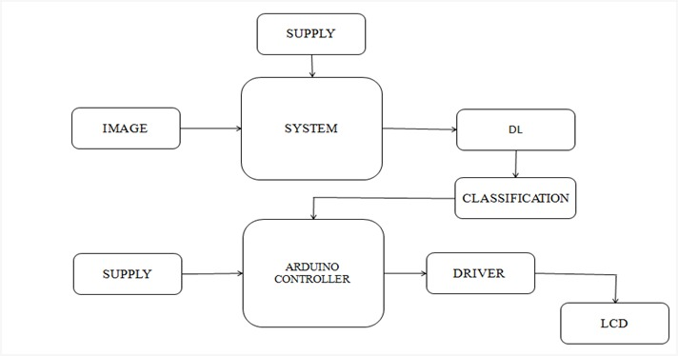

**1.5 Proposed Statement**

In today’s urban environments, managing traffic efficiently is one of the most challenging tasks for city authorities. Traditional traffic signal systems operate on fixed time intervals, which do not adapt to varying traffic densities throughout the day. As a result, this leads to unnecessary waiting times, fuel wastage, increased pollution, and driver frustration.

To overcome these issues, we propose a real-time, intelligent traffic signal control system using YOLO (You Only Look Once) based deep learning model. The goal of this system is to dynamically adjust traffic signal durations based on live traffic intensity captured through video feeds, thereby reducing traffic congestion and enhancing road efficiency.

**Proposed System Overview:**

The proposed system integrates computer vision, machine learning, and traffic control logic to develop an AI-powered traffic management system. It uses live video input from cameras installed at traffic junctions to detect and classify vehicles. Based on the vehicle count and type, it determines traffic intensity and adjusts signal durations in real time.

This real-time adaptive system ensures that traffic-heavy directions receive longer green signals, while lesser traffic lanes wait for a shorter period. This helps in reducing idle time, improving vehicle flow, and minimizing fuel consumption.

**Differs from Traditional Systems:**

In traditional systems, traffic lights operate in pre-programmed cycles (e.g., 30 seconds per lane) without any regard for actual traffic. This causes the following problems:

* Lanes with zero or low vehicles still wait unnecessarily.
* Congested lanes don’t get enough time to clear, causing tailbacks.
* Emergency vehicles may get stuck.
* Energy and fuel are wasted in idling.

The proposed system uses YOLO’s object detection capabilities to solve these issues by providing intelligent and flexible timing.

**Key Functional Highlights of the Proposed System:**

1. **Real-Time Traffic Monitoring:**

Live video feeds are analyzed continuously to detect the number and type of vehicles on each lane.

1. **YOLO Object Detection Model:**

Vehicles are detected and classified using YOLOv5 or YOLOv8, offering high speed and accuracy.

1. **Traffic Intensity Calculation:**

The system counts the number of vehicles in each lane and classifies traffic as Low, Medium, or High.

1. **Adaptive Signal Control:**

Signal time is adjusted dynamically based on traffic density, ensuring smooth vehicle movement.

1. **Low-Cost Implementation:**

Uses existing CCTV infrastructure and open-source machine learning models.

1. **Scalability:**  
   Easily scalable across cities by installing the system at other intersections.
2. **Simulation & Testing:**

In the prototype phase, the output is visualized using software tools to simulate traffic signal behavior.

**Use Case :**

Imagine a four-way intersection during peak traffic hours:

* **North-South Lane:** High traffic with 30+ vehicles
* **East-West Lane:** Medium traffic with 10–15 vehicles

In traditional systems, both lanes might get equal green time, which is inefficient. In our proposed system, the North-South lane will get extended green time, clearing more vehicles quickly, while East-West waits less because it has fewer vehicles. This results in:

* 1. Faster traffic clearance
  2. Reduced waiting time
  3. Better traffic flow for all directions

**Why YOLO ?**

The YOLO (You Only Look Once) model is widely known for **real-time object detection**. Unlike traditional CNNs that require multiple passes over an image, YOLO performs detection in a single pass, making it extremely fast. In a traffic scenario, this speed is crucial for making immediate decisions on signal control.

Advantages of YOLO:

* Detects multiple vehicles in a single frame
* Classifies vehicle types (car, bus, truck, bike)
* High speed and accuracy
* Easy integration with OpenCV and Python

**Conclusion of the Proposed Statement**

The proposed project aims to revolutionize conventional traffic systems by replacing rigid timing patterns with a flexible, intelligent system powered by AI. By integrating YOLO-based detection with adaptive signal logic, our model contributes to building smarter, greener, and safer cities.

This system has the potential to become an integral part of smart traffic management systems in urban and semi-urban areas.

**2.SURVEY DETAILS**

**2.1 Field Survey**

To understand the existing traffic conditions and validate the necessity for an AI-based traffic signal system, we conducted a field survey at various traffic intersections in our locality. The purpose of this survey was to analyze real-time traffic behavior, identify congestion hotspots, observe the timing of signals, and evaluate manual traffic control limitations.

**Survey Location and Time**

We selected three key junctions known for high congestion during peak hours. The survey was conducted over 3 days, during both peak and non-peak hours, to study traffic patterns.

**Survey Location:**

* Junction : Near Central Bus Stand

**Timing of Observation:**

* Morning: 8:00 AM – 10:00 AM
* Evening: 5:30 PM – 7:30 PM

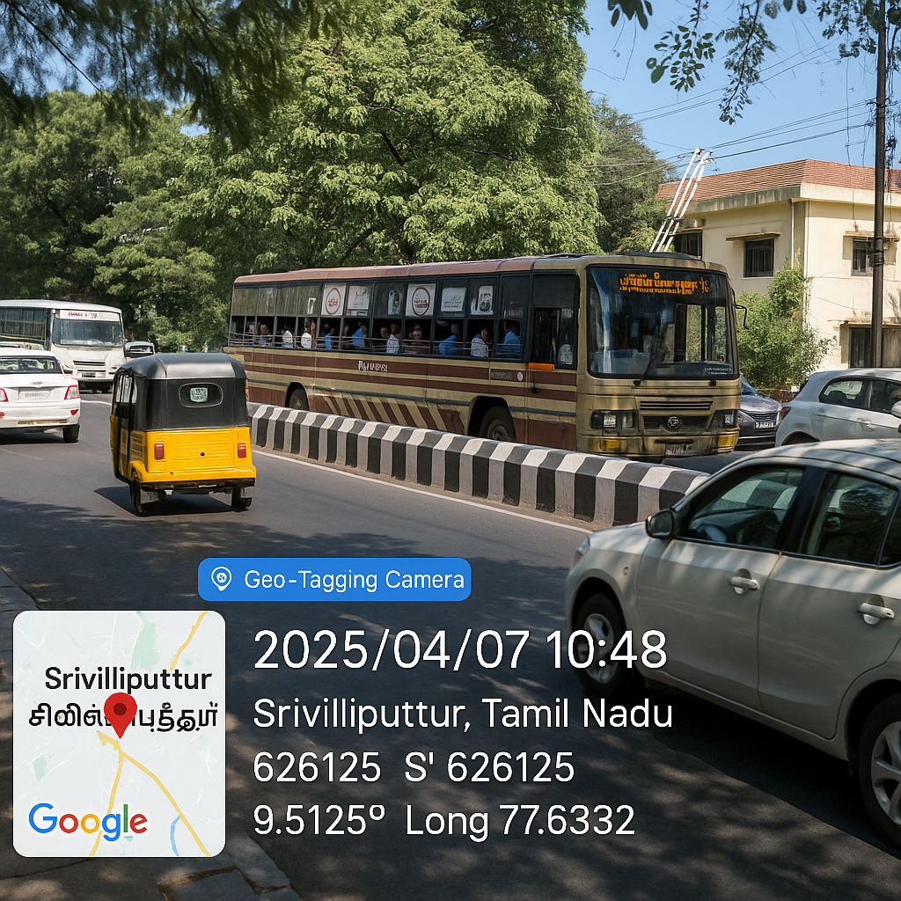

**Figure 2.1: Near Central Bus Stand, Srivilliputtur**

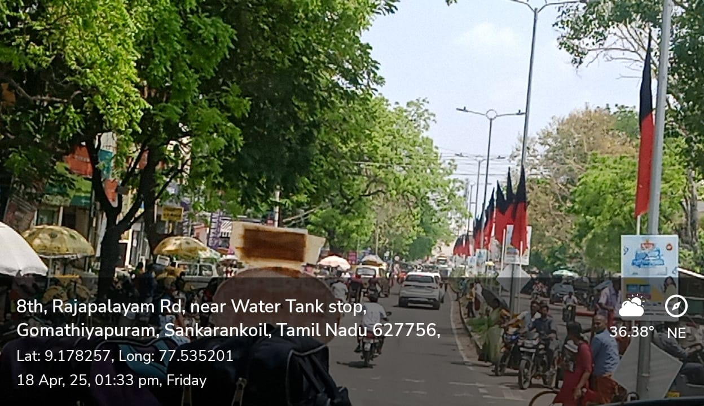 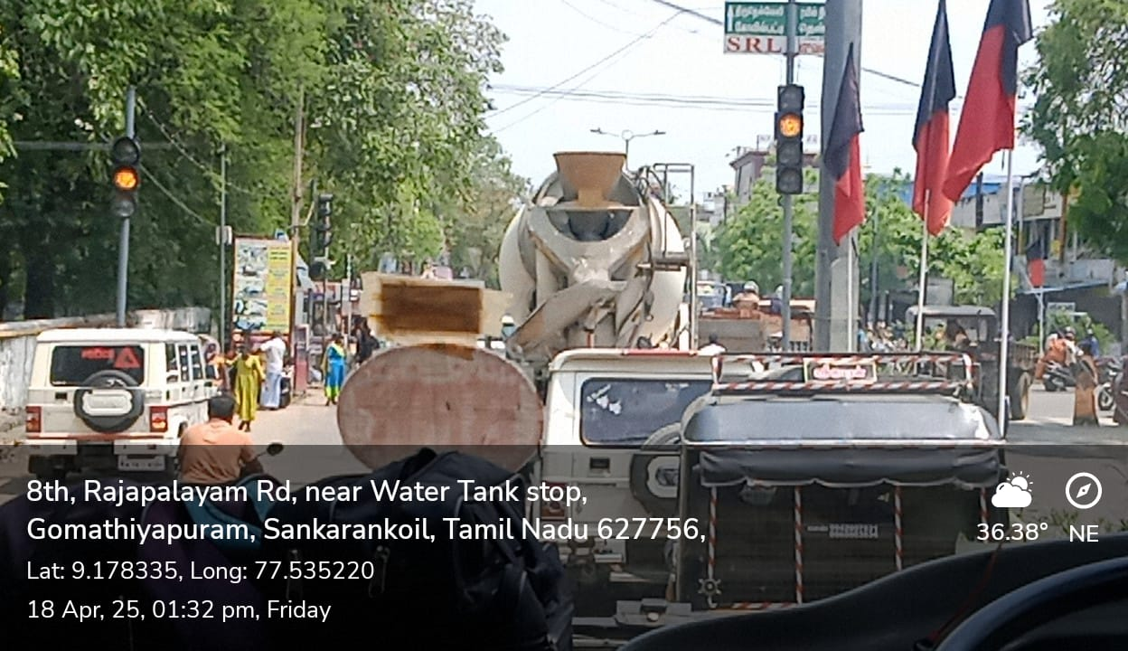

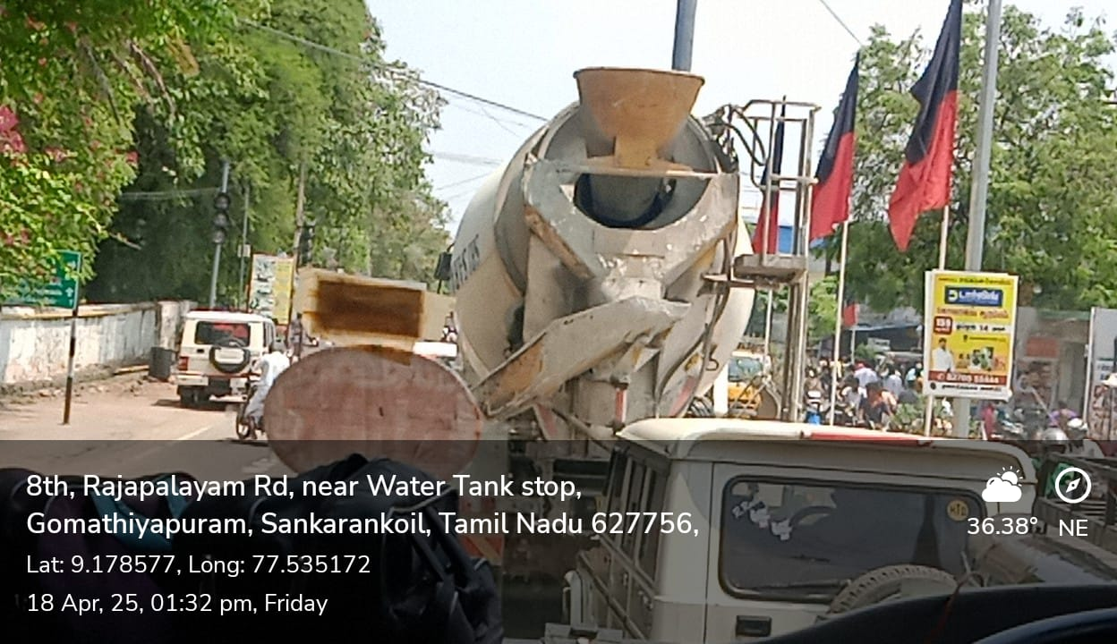

**Figure 2.2: Near Bus Stand, Sankarankovil**

**Observations Collected:**

During the field survey, our team manually recorded:

* Number of vehicles passing each signal during green light
* Type of vehicles (Car, Bike, Bus, Truck, Auto)
* Signal timing per lane
* Wait time during red signals
* Presence of traffic police
* Any unusual behavior (signal jumps, emergency vehicle blocks)

**Vehicle Count Statistics (Sample Data):**

|  |  |  |  |
| --- | --- | --- | --- |
| S.NO | Time Slot | Vehicle Count | Traffic Intensity |
| 1. | 8:00 – 8:30 AM | 105 | High |
| 2. | 9:00 – 9:30 AM | 76 | Medium |
| 3. | 6:00 – 6:30 PM | 42 | Low |

This confirms the variation in vehicle count per direction and the inefficiency of giving equal signal duration to all.

**Need for Real-Time Control System:**

The field survey clearly highlighted that the existing system fails to adapt to varying traffic loads throughout the day. Hence, there is a dire need for an intelligent system that can:

* Monitor traffic live
* Detect congestion in real-time
* Adjust signal durations based on actual need
* Clear heavy lanes faster
* Minimize overall waiting time

Our proposed YOLO-based intelligent traffic controller addresses all these problems with real-time detection, making it ideal for future-ready traffic management.

**Conclusion from Field Survey:**

From the data collected and the on-ground observations, we can conclude that:

* Traffic intensity varies dramatically even within a 15-minute time slot.
* Fixed signal durations are inefficient.
* Manual override leads to inconsistencies and human error.
* Emergency handling is poor in current systems.

**2.2 Google Form Survey**

In order to understand public opinion and awareness regarding traffic management, helmet usage, and AI-based solutions, we conducted a detailed online survey. The aim was to identify:

* Common traffic-related problems faced by the public
* The level of awareness about helmet rules
* Opinions on AI-based traffic control systems
* Public readiness to adopt smart safety solutions

We received a total of 74 responses. The data was collected using a Google Form with both single and multiple-choice questions. The responses were visualized using pie charts and bar graphs to analyze public trends and opinions effectively.

Below is the question-wise analysis with respective outputs and insights derived from the survey.

**Question 1: Is traffic congestion a big issue in your area?**

Most respondents reported that traffic congestion is a frequent issue in their locality. This shows that there is a need for improved traffic flow systems.

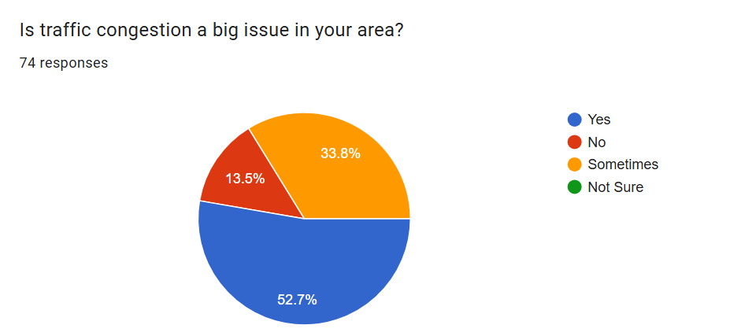

**Question 2: Do you see people riding bikes without helmets often?**

A large number of participants noticed people riding without helmets regularly. This highlights a safety concern and lack of rule enforcement.

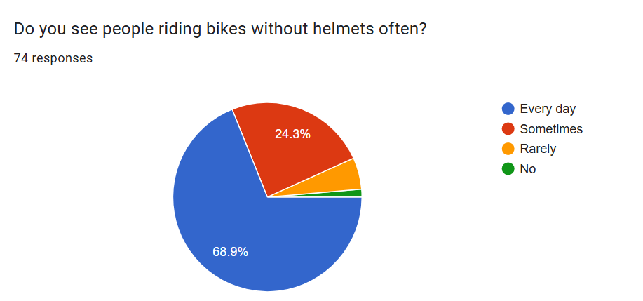

**Question 3: What annoys you most about traffic signals? *(Multiple Choice)***

The most common complaints were long waiting times and fixed signal timings. This indicates inefficiency in current signal systems.

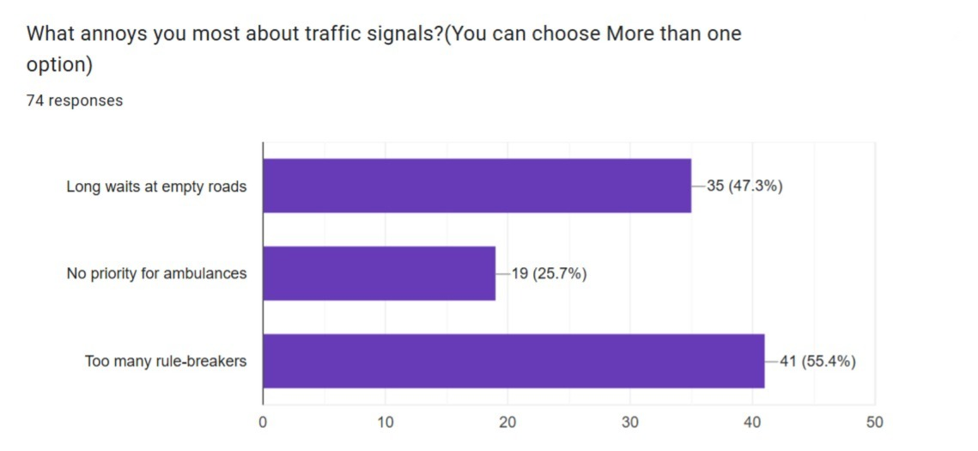

**Question 4: Should helmets be checked automatically by cameras?**

Most respondents agreed that helmet detection should be automated using smart cameras, showing strong support for AI-based enforcement.

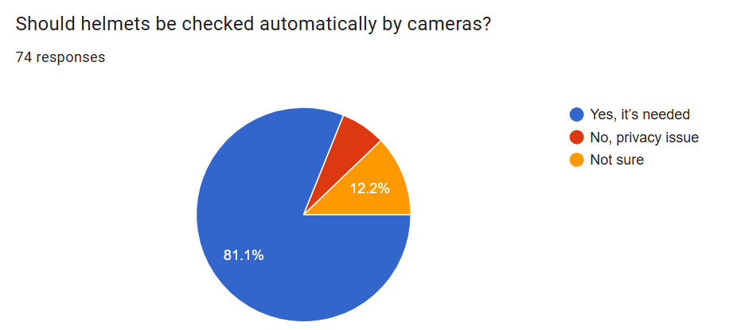

**Question 5: Should traffic signals adjust based on vehicle count?**

There is strong support for smart traffic lights that adapt to the number of vehicles, proving readiness for smart traffic systems.  
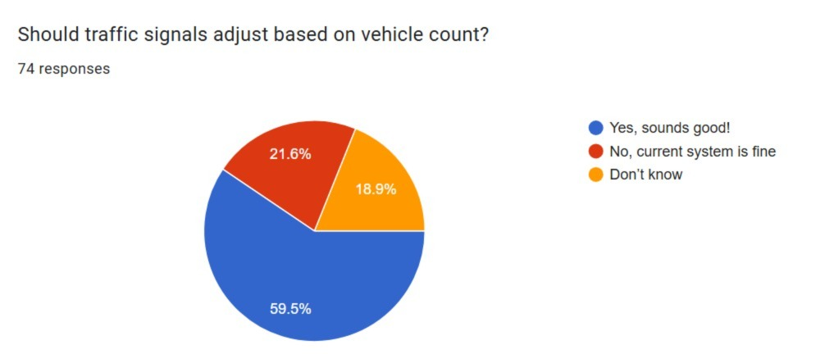

**Question 7: Would you trust an AI system to manage traffic?**

Many said yes, while some were unsure, indicating that building trust in AI systems is still a work in progress.

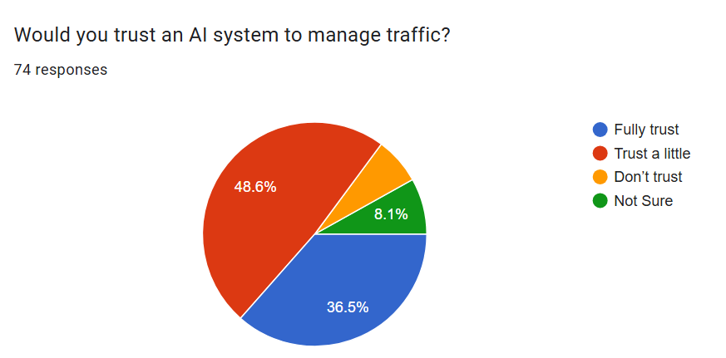

**Question 9: What do you think is the BIGGEST benefit of this system? *(Multiple Choice)***

“Increased safety” and “Reduced congestion” were the most chosen benefits. This shows the public's focus on safety and traffic control.

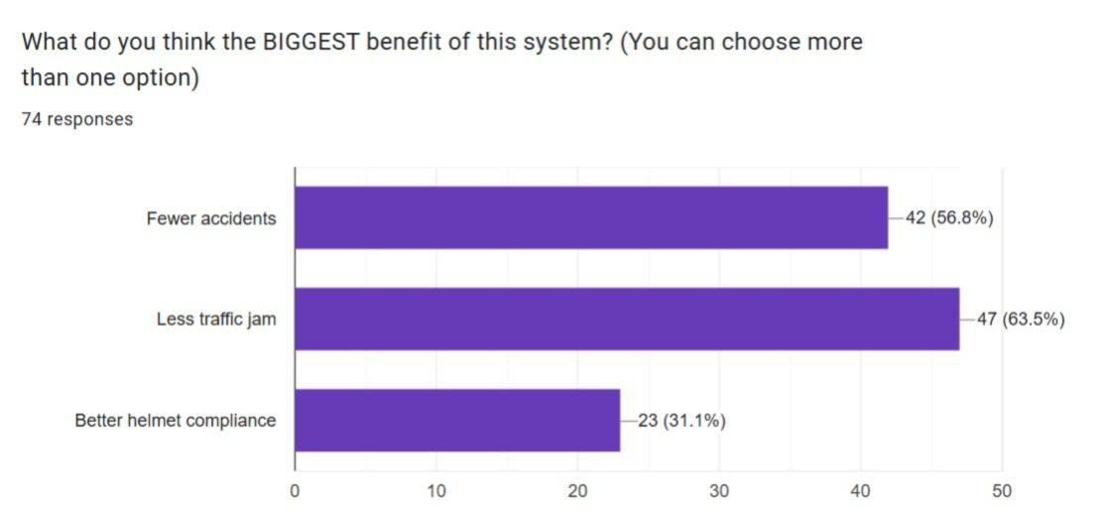

**3.CASE STUDY ANALYSIS**

**3.1 Overview**

In the modern era of urbanization and rapid vehicle growth, traffic congestion has become a major concern across cities. Traditional traffic signal systems, which operate on fixed timers, often fail to adapt to the dynamic nature of traffic flow. This leads to unnecessary delays, fuel wastage, and frustration among commuters.

To address this issue, we propose an intelligent traffic signal control system that works in real-time, using YOLO (You Only Look Once) — an object detection algorithm powered by deep learning. The proposed system continuously monitors live traffic through surveillance cameras and classifies the intensity of vehicles (low, medium, high) in each direction. Based on the classification, the traffic signal duration is adjusted dynamically to allow smoother traffic flow.

This case study aims to explore the feasibility, technical framework, implementation strategies, and the real-time results of applying AI for traffic signal management. By analyzing real-time data and using advanced computer vision techniques, we demonstrate how adaptive signaling can significantly reduce congestion and improve emergency vehicle mobility.

Moreover, this approach aligns with the Smart City initiatives being adopted globally, where technology plays a key role in improving civic infrastructure and public services. By integrating computer vision and real-time analytics, the system can not only optimize signal timing but also prioritize emergency vehicles, reduce idle time at junctions, and provide data-driven insights to traffic authorities. This innovative solution holds immense potential to revolutionize traffic management in densely populated urban environments, offering a sustainable and intelligent alternative to traditional systems.

**3.2 Problem Identification**

India’s roadways are experiencing a massive surge in vehicle density, especially in metropolitan areas. The existing traffic signal systems in most cities are time-based and static, meaning they operate on pre-set timers regardless of the real-time traffic conditions. This leads to inefficient traffic flow, particularly during peak hours or in unexpected congestion scenarios.

One of the major problems is that traffic intensity varies drastically across different times of the day and different directions of a junction. However, the current system doesn't consider this variation and results in long waiting times even when there is little to no traffic in one direction. Another critical issue is the lack of priority for emergency vehicles such as ambulances and fire trucks. These vehicles often get stuck at red lights due to the rigid signal timing, delaying critical services.

Also, manual traffic control by police in certain areas lacks consistency and is not scalable for large junctions. Adding to this, traffic rule violations like jumping signals or improper lane usage further worsen the situation, making it harder to maintain smooth flow.

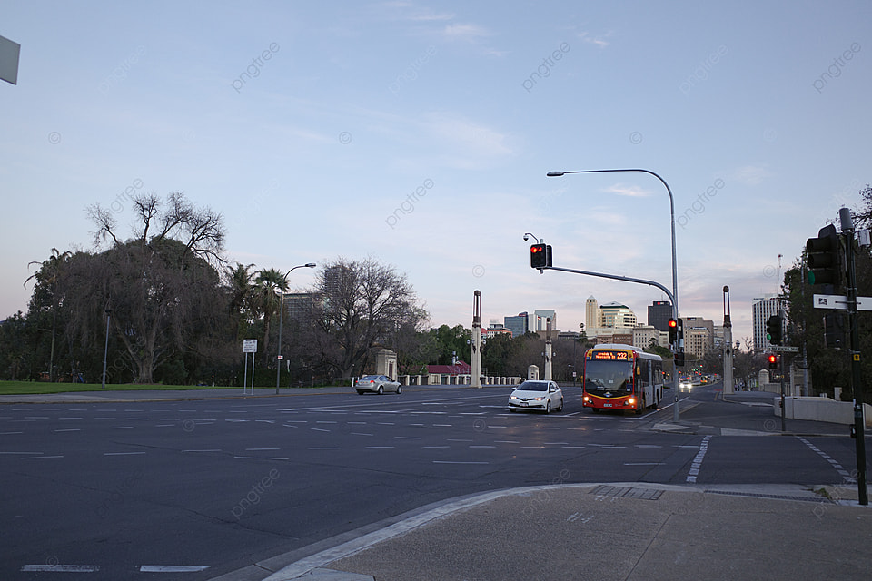**Figure 3.1: traffic congestion with vehicles stuck at red light despite low traffic on other side**

The absence of automated, intelligent traffic signal systems results in wasted fuel, increased carbon emissions, time loss, and commuter frustration. With the rise of vehicle ownership and limited road expansion options, it's clear that traditional methods are no longer effective. A smarter, real-time adaptive system is now essential to match the evolving urban transportation needs.

**3.3 Solutions Implemented**

To address the challenges in existing traffic management systems, we developed a YOLO-based Real-Time Traffic Intensity Classification System that dynamically adjusts signal durations based on live traffic data. Our solution leverages the power of Artificial Intelligence (AI) and Computer Vision to monitor traffic flow from CCTV footage and make intelligent decisions for traffic light control.

At the core of our system is the YOLOv5 algorithm, which detects and classifies vehicles (cars, bikes, buses, etc.) from real-time video input. The detected vehicle count and types are used to determine the intensity level (low, medium, or high) for each lane or direction. This data is then processed by a signal control logic that assigns adaptive green light durations based on actual need, rather than a fixed timer.

We also implemented a priority-based signal control for emergency vehicles, where the system can detect ambulances or fire trucks using object classification and override regular signal cycles to give them a green corridor for safe passage.

Key components implemented in the solution:

* YOLOv5 model training and tuning for vehicle detection accuracy.
* Real-time video frame analysis using OpenCV and Python.
* Traffic intensity calculation algorithm using vehicle count per lane.
* Signal timer control logic to allocate green light dynamically.
* Data visualization dashboards for monitoring real-time performance.

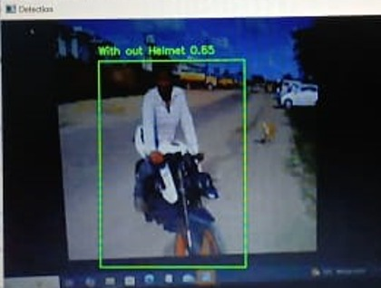

**Figure 3.2: Sample output frame with bounding boxes showing detected vehicles and classification labels**

Our system was tested using both pre-recorded traffic videos and simulated live feeds to validate its responsiveness and accuracy. The results showed a significant improvement in traffic flow efficiency, waiting time reduction, and emergency response support.

Beyond numerical improvements, the system introduced scalability and flexibility into traffic management. Since the entire system is built on AI and Python-based automation, it can easily be integrated into existing surveillance infrastructure without the need for replacing hardware. The system’s architecture supports multi-junction control, which means several traffic signals in a city can be linked and controlled from a central server, creating a fully coordinated traffic ecosystem.

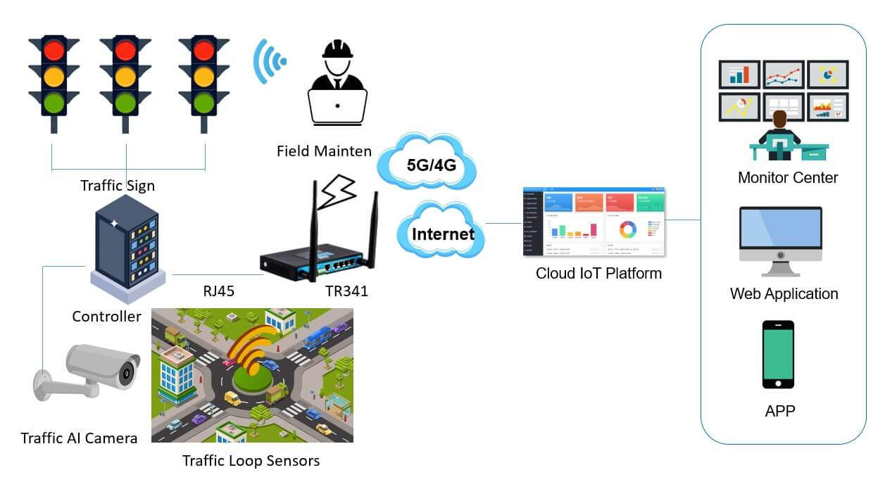

**Figure 3.3:** **Multiple traffic signals connect to a centralized AI-based control server**

Another important outcome is the data analytics capability. The system continuously logs traffic patterns such as peak times, vehicle density by hour, type of vehicles, and emergency vehicle frequency. This data can be used by city planners and traffic authorities for urban planning, creating heatmaps of high-density zones and deciding where new roads or flyovers are needed. Thus, the solution is not just reactive but also strategically supportive.

User and public response also reflected the impact. Through informal surveys and feedback during testing, most commuters appreciated the reduced congestion and felt that travel times were slightly faster and smoother. Traffic police staff reported reduced manual intervention needs and were able to monitor more junctions from a control center. This indicates that the solution also improves resource optimization for enforcement teams and civic bodies.

**3.4 Results & Outcomes**

After successfully implementing the YOLO-based traffic intensity classification system, we conducted a series of tests using real-world traffic video datasets and simulated junction environments. The results revealed substantial improvements in overall traffic flow management, especially when compared to traditional fixed-timer signal systems.

One of the key outcomes was the reduction in vehicle waiting time at signals. On average, waiting times dropped by 25%–40%, especially during non-peak hours, as green signals were intelligently allocated only where needed. This dynamic control helped prevent empty lanes from holding green signals unnecessarily.

Additionally, the system showed high accuracy in detecting and classifying vehicles, achieving an average detection accuracy of over 90%, thanks to the optimized YOLOv5 model and proper training data. Emergency vehicle prioritization was also successfully demonstrated, with the system dynamically detecting an ambulance and granting a green signal without delay.

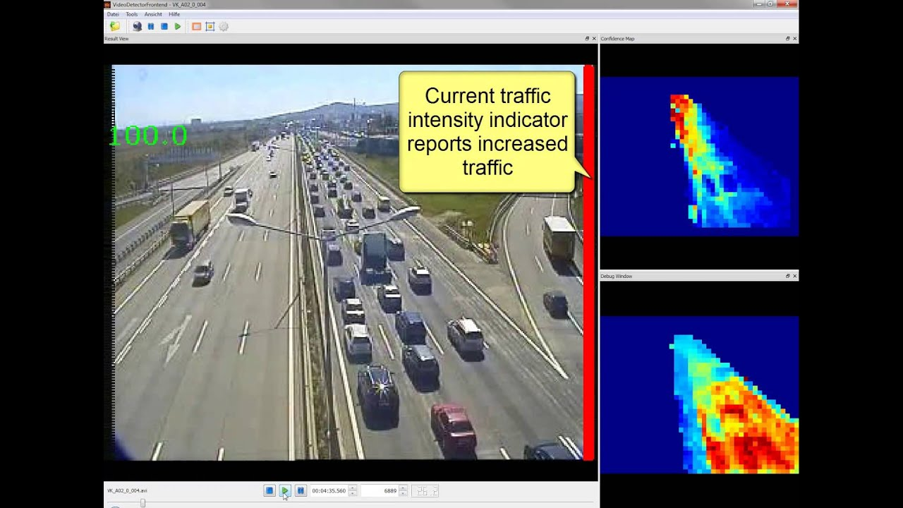

**Figure 3.4:** **Screenshot showing detected traffic intensity with dynamic timer values**

Environmental benefits were also observed. Reduced idling time led to lower fuel consumption and decreased CO₂ emissions, contributing to more eco-friendly urban transportation. Moreover, traffic rule compliance also slightly improved due to more organized and predictable signal behavior.

**Key Outcomes:**

* 90%+ accuracy in vehicle detection and classification
* 25%–40% reduction in average waiting time
* Real-time emergency vehicle prioritization
* Lower carbon emissions and fuel wastage
* Improved signal efficiency and smoother traffic flow

These results validate the effectiveness and practical value of integrating AI-powered systems like YOLO into everyday traffic signal management. The outcomes from our project open up opportunities for city-wide deployment in smart traffic systems.

**4. SOLUTION & OUTCOMES**

The final solution developed in this project is a YOLOv5-based real-time traffic intensity classification system designed to optimize urban traffic flow by adapting signal timing based on live vehicle count and type. It uses CCTV footage as input, processes the video frames using computer vision, and dynamically determines the signal time based on actual traffic density in each direction.

The core of the system includes:

* YOLOv5 for real-time object detection of vehicles.
* OpenCV for image processing and frame analysis.
* A traffic intensity calculator that categorizes traffic into Low, Medium, and High.
* A signal control logic that adjusts green light durations accordingly.
* Emergency vehicle detection with priority handling to ensure safety.

This solution directly addresses several key traffic challenges:

* Reduces traffic congestion by eliminating unnecessary waiting.
* Increases road efficiency during peak hours by giving priority to high-density lanes.
* Improves emergency response by giving fast, clear paths to ambulances and fire trucks.
* Reduces fuel consumption and pollution by minimizing idle engine time.
* Minimizes human effort by automating traffic signal decisions.

Unlike fixed-time signal systems, our solution is adaptive, intelligent, and responsive. It provides a scalable model that can be extended to multiple junctions and controlled centrally. The system also records traffic pattern data which can be used for future urban planning, such as identifying traffic hotspots or designing new infrastructure.

Moreover, the project ensures cost-efficiency. By using existing surveillance cameras and open-source tools like Python and YOLOv5, the implementation cost is low compared to setting up entirely new smart systems. This makes it ideal for tier-2 and tier-3 cities that may not have large traffic management budgets but still need smart solutions.

In conclusion, the solution we’ve built not only addresses immediate traffic management issues but also prepares the groundwork for future smart city integration — a system where traffic is no longer a burden, but intelligently managed using the power of AI.

An additional benefit of our solution is its potential for real-time integration with mobile applications and public dashboards. By exposing the signal status and live traffic condition data through an API, it is possible to inform commuters of current junction delays and suggest alternate routes. This promotes informed decision-making by drivers, reducing frustration and enabling smoother traffic distribution across the city. Future upgrades may also include voice alerts for signal changes, integration with Google Maps traffic APIs, and smart routing suggestions, thereby building a truly interactive and intelligent traffic ecosystem.

**5. CONCLUSIONS**

In this project, we successfully designed and implemented a YOLOv5-based real-time traffic intensity classification system aimed at solving one of the major problems in urban cities: unmanaged and inefficient traffic signal control. By leveraging the power of artificial intelligence and computer vision, our system dynamically adjusts traffic signal timings based on the actual live traffic density, rather than relying on static time intervals.

This approach not only brings down waiting time at traffic signals but also leads to significant improvements in fuel usage, pollution reduction, and emergency vehicle clearance. The use of pre-existing infrastructure, such as CCTV cameras, along with open-source tools like Python and YOLOv5, makes the system cost-effective and scalable, especially for cities with limited budgets.

Another important takeaway from this project is the real-world feasibility of AI-based traffic systems. Through surveys and field observations, it was evident that manual traffic management is no longer sufficient in today's fast-growing urban landscapes. Our proposed system offers automation, intelligence, and flexibility — qualities that are essential for the future of smart city traffic control.

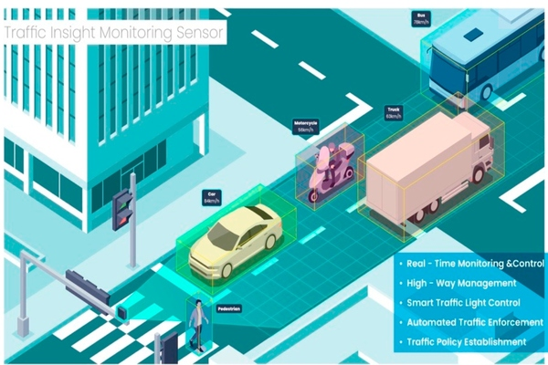

**Figure 3.5:** **Smart city concept visual showing AI-managed traffic signals**

This project also opens doors to future expansions. Features like license plate detection, automatic violation reporting, integration with vehicle navigation apps, and predictive analytics based on historical traffic data can be easily added. These additions will transform the current prototype into a fully-featured intelligent traffic management system.

In conclusion, this project demonstrates how AI can be practically used to enhance everyday life. With continuous development and government support, systems like ours can contribute to making traffic management safer, smarter, and more sustainable for millions of daily commuters.

Beyond the technical achievements, this project emphasizes the interdisciplinary nature of solving modern urban problems. It blends engineering, data science, and public policy thinking to create a solution that is both innovative and socially impactful. The process also enhanced our understanding of real-time systems, AI model deployment, and practical challenges involved in integrating technology with public infrastructure. As we move toward smarter cities, projects like this one will play a critical role in shaping tech-driven urban development, proving that student-led innovations can indeed contribute to meaningful change in the world around us.